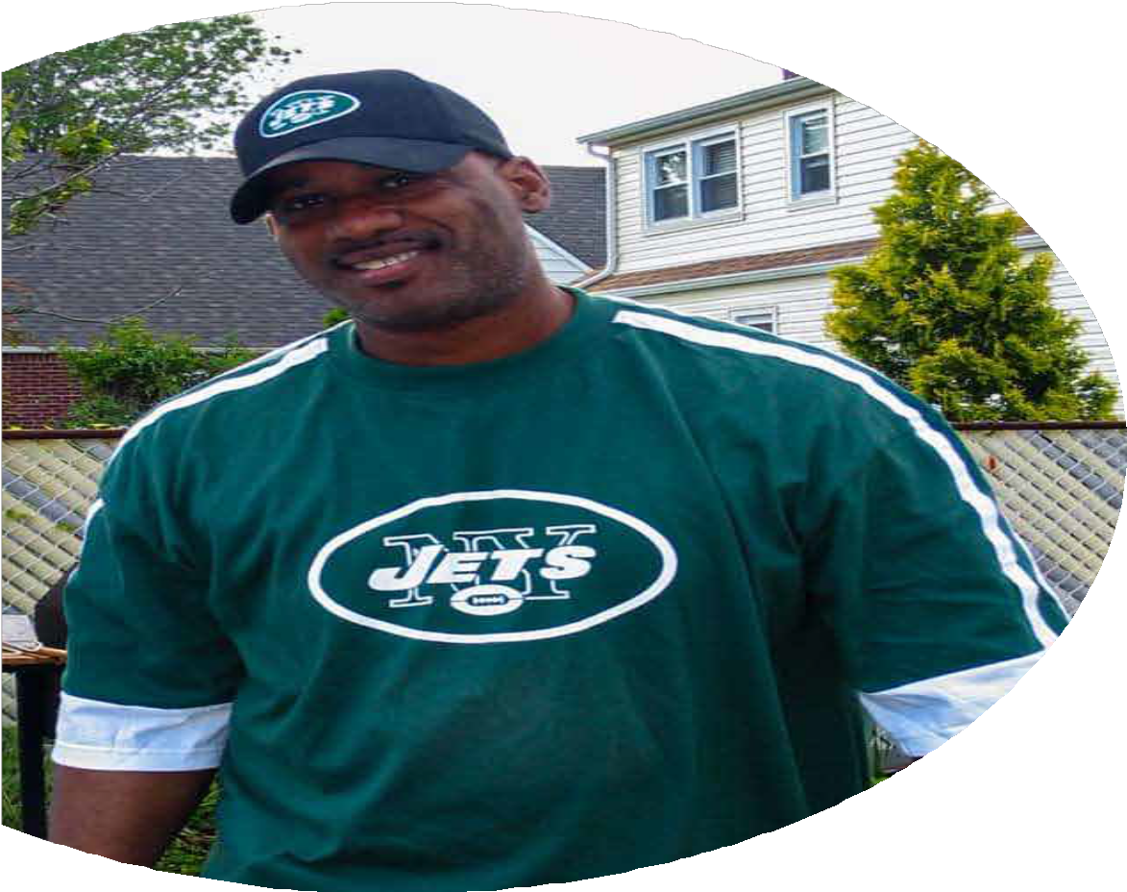

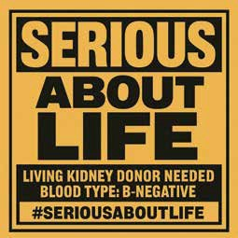
HELP

Cleveland “Serious” Delaney
Find a Kidney Donor
Cleveland is a loving father, friend, and music artist. He has spent his life helping others.

Now he needs our help.
Cleveland’s kidneys are very sick.
He needs a new kidney to stay alive.
A living kidney donor gives one kidney and can still live a full and healthy life.

The ﬁrst step is a simple
health check.
All medical costs for the donor are covered.
If you want to help, please visit the website below or scan the
code to learn more.

Visit: SeriousAboutLife.org
Please share this ﬂyer. You may help save a life

